Issuing a Partial Statement of Account

|  |  |  |  |  |
| --- | --- | --- | --- | --- |
| **Ver** | **Date** | **Author** | **Comments** | **Reviewed by** |
| 1 | 16/11/2020 | Tom Bell | CRIM 0333 | TBC |
|  |  |  |  |  |

Requirements 2

Prerequisites 2

Solution Overview 2

Solution Details 2

Security 3

Companies 3

Data Migration 3

Test Steps 3

Technical Implementation 3

Requirements

From the Customer Analysis screen and Ledger Tab, the system must be able to select one or many items and issue a Partial Statement of Account Report to the customer based on the selected items.

Prerequisites

CRIM 0332 - Partial Statement of Account Report.

Solution Overview

**Context**: A Credit Analyst needs to issue an ad hoc Partial Statement of Account to a customer.

**Solution**: From the Customer Analysis screen, the Credit Analyst selects one or many open items. Once selected, RMB the header of the Customer Analysis screen and see the option to “Print Partial Statement of Account”.

From there the system will have the report “Partial Statement of Account” (see CRIM 0332) attached to the “Report Format and Output” dialog box.

**High-level overview:**

1. On Customer Analysis screen, highlight one of many invoices.
2. RMB header of screen, select “Print Partial Statement of Account”.
3. Credit Analyst can change parameters in the dialogue box that appears as required.
4. Select “Ok”.
5. Partial Statement of Account Report attached in “Report Format & Output” dialogue box.
6. Tick “Email” check box and Customer’s email address is prepopulated in the email field.
7. Select “Ok” which sends the report to the customer.

Solution Details

This function should only populate the report based on the selected items and not all open items on the Customer’s Account. The following section will detail where this functionality will be made available from.

**Customer Analysis Screen**

The below screenshot shows the RMB options from the Header of the Customer Analysis Screen. Once the Credit Analyst has selected one or many open items they will RMB the header of this screen. Here the option to “Print Partial Statement of Account” must be available.

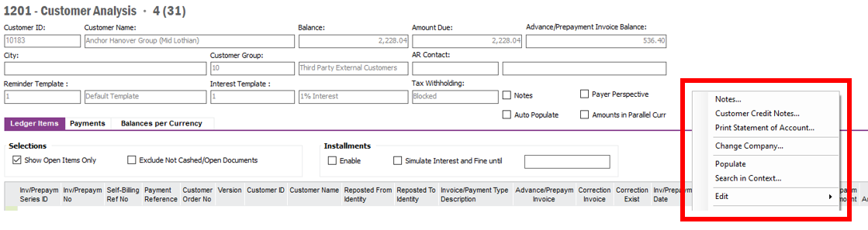

The below screenshot shows an example of the options that are available after RMB and selecting “Print Customer Statement”. The Partial Statement process must be simmilar, with the exception of attaching the “Partial Customer Statement of Account” report (red box) by default (see CRIM 0332) and with only generating the report based on the one or many open items selected.

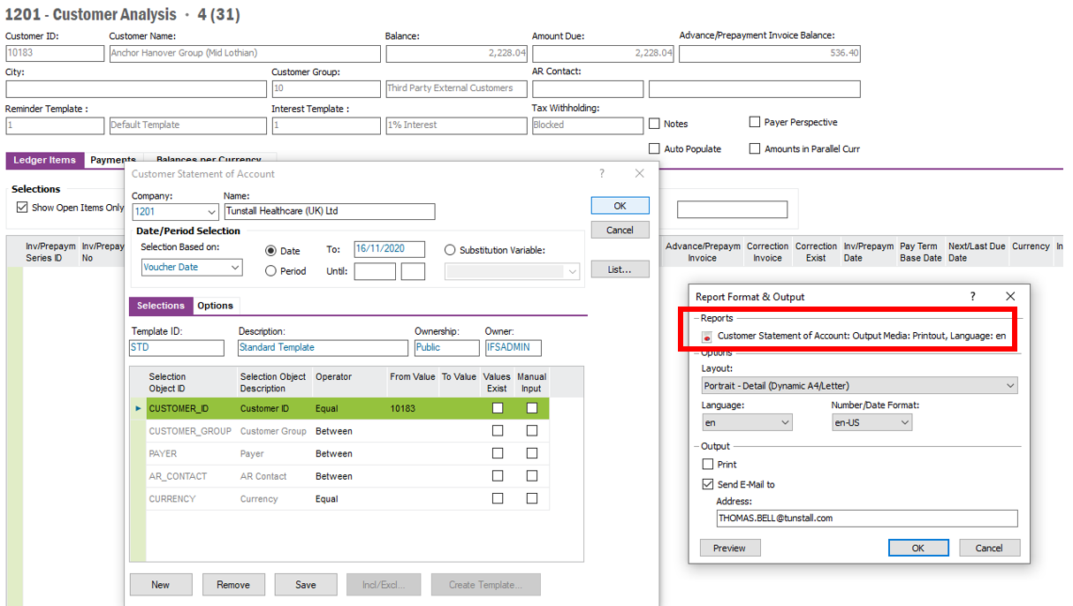

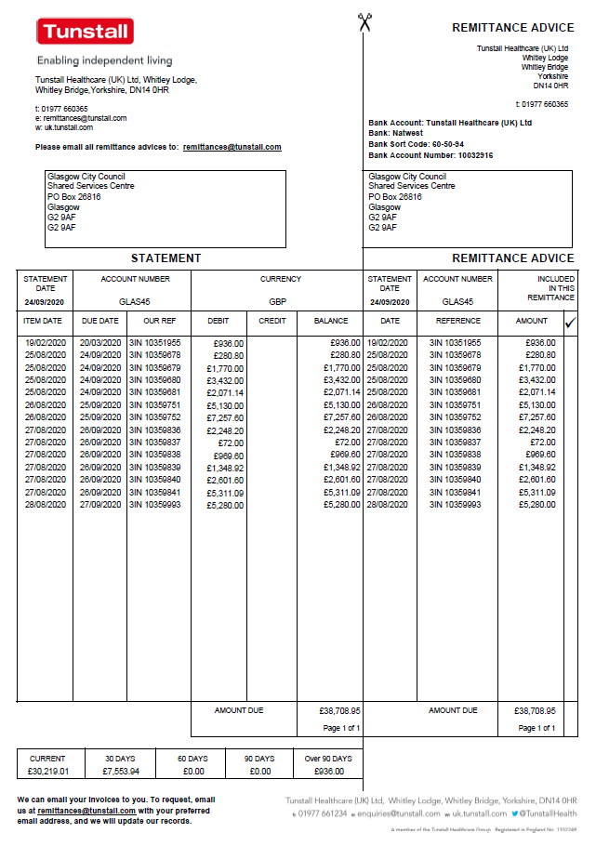

The above screenshot shows an example of a “Statement of Account Report” that is currently sent out to the customer. See CRIM 0332 for more details of the new report.

Technical.

Field Definitions.

<New Field/CLU Definition>

|  |  |  |  |  |  |  |
| --- | --- | --- | --- | --- | --- | --- |
| New DB Object Name | DB Object Item/Field Names | Item Description | Item Data Type | Item Syntax | Calculation Spec, if Derived | LOVs/Enums/Is Mandatory? |
|  |  |  |  |  |  |  |
|  |  |  |  |  |  |  |
|  |  |  |  |  |  |  |
|  |  |  |  |  |  |  |
|  |  |  |  |  |  |  |
|  |  |  |  |  |  |  |
|  |  |  |  |  |  |  |
|  |  |  |  |  |  |  |
|  |  |  |  |  |  |  |
|  |  |  |  |  |  |  |
|  |  |  |  |  |  |  |
|  |  |  |  |  |  |  |

Security

<Define security controls> (Who needs access to this and will it be restricted from any other users etc)

* Finance Manager.
* Credit Manager.
* Credit Controllers.

Companies

Applies to the following companies. All.

|  |  |
| --- | --- |
| **Company** | **Required (Y/N)** |
| 1201 | Y |
| TBC |  |
|  |  |

Data Migration

<Describe any data migration impacts this development may have – i.e additional data to be migrated>

Test Steps

<Steps that needs to be taken to test this change. Please provide expected results> Updated post solution.

|  |  |  |
| --- | --- | --- |
| **No** | **Script\Test Steps** | **Expected Result** |
| 1 | In the Customer Analysis screen. RMB one or many items. RMB header of screen and select “Print Partial Statement” | Brings up the report editor dialogue box. |
| 2 | Once parameters have been set, select “OK”. | Opens “Report Format and Output” dialogue box with Partial Statement of Account Report Attached. |
| 3 | Select “Preview” | Shows preview of Statement and only contains the statement for selected items. |
| 4 | Check “Email” box. | Email is sent to the email address and see customer’s email address prepopulated. |
|  |  |  |
|  |  |  |
|  |  |  |
|  |  |  |

Technical Implementation

<Completed by the technical developer - Technical solution, list packages, functions, Custom menus created etc >

1. The related configurations are under the “EA_Finance” Application Configuration Package (ACP).
   * Deploy the EA_Finance package by clicking on “Publish”.
2. Go to the “Customer Analysis” window, under “Ledger Items” tab,
   * Applying the configurations.
     1. RMB on the table body.
     2. Hover over “Custom Objects” menu and click in the “Reload Configuration” menu.
     3. A “Question” window will pop up, click the “OK” button within the window.
   * Adding the related columns.
     1. RMB on the table header “Invoice Periods”.
     2. Click on the “Column Chooser” menu.
     3. Under the “Hidden Columns” box select the 2 columns, “Quick Report” and “Quick Report User”.
     4. By clicking the “Single Right Arrowhead” button, add the selected columns to the “Visible Columns” box and click “OK” when done.
3. Grant permissions to “Partial Statement of Account Quick Report” quick report.
   * Permission Sets: IFS_ALL
4. How to use:
   * Go to the “Customer Analysis” window.
   * Populate the window with data.
   * Under “Ledger Items” tab,
     1. Select the records from the table that needs to be in the Quick Report.
     2. RMB on the table body.
     3. Click on “Select for Quick Report” menu.
     4. The “Quick Report” column will show the records which were selected by the currently logged in user to be viewed as a “Partial Statement of Account Quick Report”.
     5. RMB on the table body again and click on “Partial Statement of Account QR…” menu.
     6. A Quick Report will then be generated for the selected records.
   * Clean up.
     1. After viewing the Quick Report, return to the “Customer Analysis” window and re-populate the window with data.
     2. Under “Ledger Items” tab, select the records that needs to be cleaned up from the Quick Report selection.
     3. RMB on the table body and click on “Clear Quick Report Selection” menu.